🎯 AI-Powered QA Bug Reporting System

📘 Implementation & Design Document

📑 Table of Contents
- 🔍 Problem Statement
- 💡 Proposed Solution
- 🎯 Expected Outcome
- 🏗️ High-Level Architecture
- 🧩 System Components
- 🔗 Data Flow & Integration
- 🔐 Security & Data Handling
- 🧪 Testing Strategy
- 🚀 Scalability & Future Enhancements
- 📌 Conclusion

1. 🔍 Problem Statement
In modern QA workflows, bug reporting suffers from several inefficiencies:
- ❌ Unstructured bug descriptions from users
- ❌ Missing critical details (environment, steps, severity)
- ❌ Duplicate bug submissions wasting team effort
- ❌ Manual triaging and validation delays
- ❌ Lack of centralized intelligence for historical bugs
These issues lead to:
- Increased QA overhead
- Slower release cycles
- Poor communication between QA, Dev, and Product teams

2. 💡 Proposed Solution
An AI-powered automated bug reporting system that:

✅ Key Capabilities
- Converts raw user input into structured QA bug reports
- Uses LLM (OpenAI) for intelligent analysis and formatting
- Detects duplicate bugs using vector embeddings
- Automates approval workflow via Slack
- Integrates with:
  - 📊 Google Sheets (tracking)
  - 🎫 Jira (issue creation)
- Stores historical bugs in a Vector Database for semantic search

3. 🎯 Expected Outcome
Area | Improvement
Bug Quality | +80% structured & complete reports
Duplicate Reduction | -60% duplicate submissions
QA Efficiency | +50% faster triaging
Time to Ticket | Reduced from minutes → seconds
Collaboration | Real-time Slack approvals

4. 🏗️ AI QA Bug Reporting – Full Architecture
[ User Input (Chat Trigger) ]
│
▼
[ AI Agent - Bug Reporting (LLM) ]
│
▼
[ Bug Report Formatter ]
│
▼
[ Report Parser ]
│
▼
[ Format Search Query ]
│
▼
[ Generate Bug Embedding ]
│
▼
[ Search Similar Bugs (Vector DB) ]
│
▼
[ Ensure Data Flow (Merge) ]
│
▼
[ Evaluate Similarity ]
│
▼
┌───────────────────────┐
│ Is Duplicate? │
└─────────┬─────────────┘
│
┌─────────┴─────────┐
│ │
YES NO
│ │
▼ ▼
[ Notify Duplicate ] [ Store in Google Sheets ]
(Slack) │
▼
[ Send for Approval (Slack) ]
│
▼

┌───────────────────┐
│ Approved? │
└─────────┬─────────┘
│
┌────────────┴────────────┐
│ │
NO YES
│ │
▼ ▼
[ Rejected Notification ] [ Create Jira Issue with attachment if any ]
(Slack) │
▼
[ Extract Jira Info (Code) ]
│
▼
[ Prepare Bug for Storage ]
│
┌────────────────────┴────────────────────┐
│ │
▼ ▼
[ Generate Storage Embedding ] [ Prepare Storage Document ]
│ │
└───────────────┬─────────────────────────┘
▼
[ Store Bug in Vector DB ]
│
▼
[ Update Google Sheet with Jira ID ]
│
▼
[ Success Notification (Slack) ]

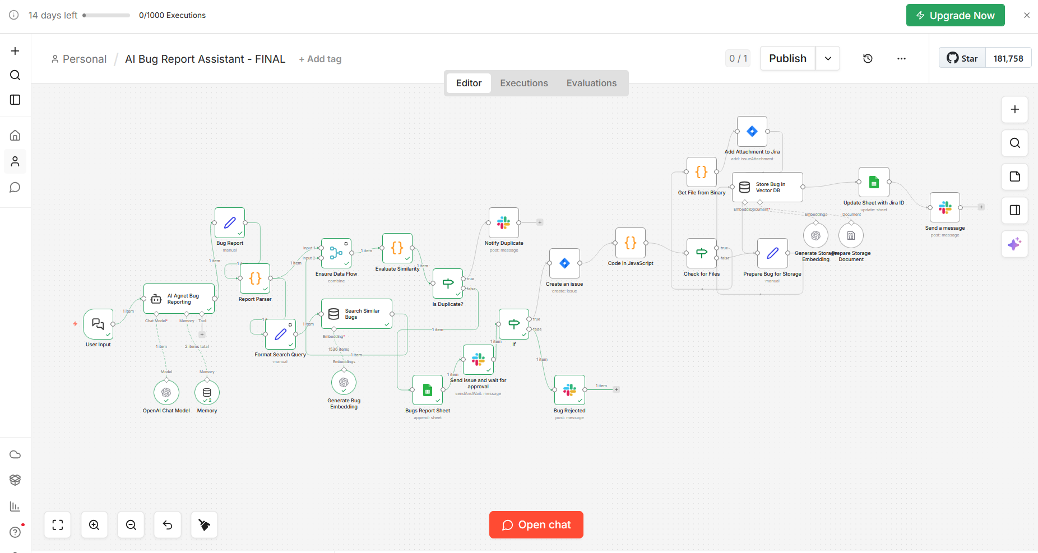

5. 🧩 System Components

5.1 🤖 LLM (Large Language Model)
- Model: gpt-4.1-mini
- Responsibilities:
  - Generate structured bug reports
  - Infer missing fields (severity, priority)
  - Normalize user input

5.2 🔄 Workflow Engine
- Tool: n8n
- Handles:
  - Orchestration
  - Conditional logic
  - API integrations

5.3 🧠 Vector Database
- Type: In-memory vector store
- Purpose:
  - Store embeddings of previous bugs
  - Enable semantic similarity search

5.4 🧠 AI Agent Memory
memory lets your AI agent remember past interactions and context, instead of treating every message as new.
Without memory:
- Agent forgets everything each run
- Users repeat themselves
- No personalization
With memory:
- Ongoing conversations
- User preferences remembered
- Smarter responses over time

5.5 📊 Data Storage
- Google Sheets:
  - Bug tracking
  - Metadata storage
  - Jira linkage

5.6 🎫 Issue Tracking
- Jira:
  - Automated ticket creation
  - Structured issue descriptions

5.7 💬 Communication Layer
- Slack:
  - Approval workflow
  - Notifications:
    - Duplicate detected
    - Approved
    - Rejected

6. 🔗 Data Flow & Integration

🔄 End-to-End Flow
- User Input
  - Raw bug description submitted
- AI Processing
  - LLM generates structured report
- Parsing
  - Extract fields:
    - Title, Severity, Steps, etc.
- Embedding Generation
  - Convert bug into vector representation
- Similarity Search
  - Compare against existing bugs
- Decision Node
  - If duplicate → Notify user
  - Else → Continue
- Storage
  - Save bug in Google Sheets
- Approval Workflow
  - Slack message with approval buttons
- Decision Handling
  - Approved → Create Jira ticket
  - Rejected → Notify user
- Final Storage
- Store embedding for future detection

7. 🔐 Security & Data Handling

🔒 Authentication
- OAuth2 used for:
  - Google Sheets
  - Slack
  - Jira

🔑 API Security
- Secure credential storage in n8n
- No hardcoded secrets

📦 Data Privacy
- Sensitive data is:
  - Not exposed externally
  - Processed within controlled workflows

🧠 AI Safety
- Controlled prompt engineering
- Strict output formatting rules

8. 🧪 Testing Strategy

8.1 Functional Testing
- Validate:
  - Bug parsing accuracy
  - Jira ticket creation
  - Slack approvals

8.2 AI Validation Testing
- Test scenarios:
  - Missing fields
  - Ambiguous inputs
  - Invalid bug reports

8.3 Duplicate Detection Testing
- Validate similarity thresholds (e.g., 0.85)
- Test:
  - Exact duplicates
  - Partial matches
  - Edge cases

8.4 Integration Testing
- End-to-end workflow validation:
  - Input → Jira → Slack → Storage

8.5 Performance Testing
- Measure:
  - Response time
  - Embedding generation latency

9. 🚀 Scalability & Future Enhancements

🔮 Planned Improvements
- ✅ Replace in-memory vector DB with:
  - Pinecone / Weaviate / FAISS
- 📊 Add analytics dashboard:
  - Bug trends
  - Severity distribution
- 🤖 AI Enhancements:
  - Auto-prioritization based on business impact
  - Root cause prediction
- 🔁 CI/CD Integration:
  - Trigger tests automatically on bug creation
- 🧠 Feedback Loop:
  - Learn from rejected/approved bugs

10. 📌 Conclusion
This solution transforms QA workflows by combining:
- 🤖 AI intelligence
- 🔄 Workflow automation
- 🧠 Semantic search

🚀 Key Value:
- ✅ Faster bug reporting
- ✅ Duplicate detection
- ✅ Standardized QA reports
- ✅ Seamless integration with Jira, Slack, and Google Sheets

